Appendix One - Accident & Incident Report Form
To be completed in the event of any accidents/injuries to Looked After Children. Please complete and return to your Supervising Social Worker within 24 hours of accident/injury occurring.
Injured Person
Full Name: |  | Male / Female | Date of birth:
Address:

Date of accident/incident & time:
Description of accident or incident:
(Please provide a description of events. For example, what happened? Who was present? Where it took place? What did you do?

What injuries were sustained? Please use the attached body map to record the injury.)
Signature of carer(s)

Date;
Signature of supervising social worker;
Date;
Signature of Fostering Team Leader
Date

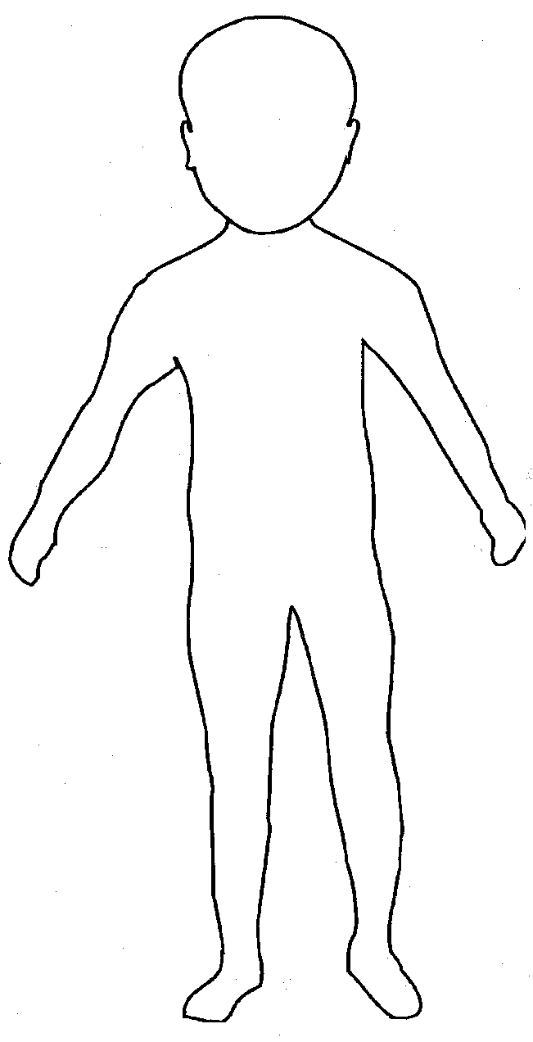
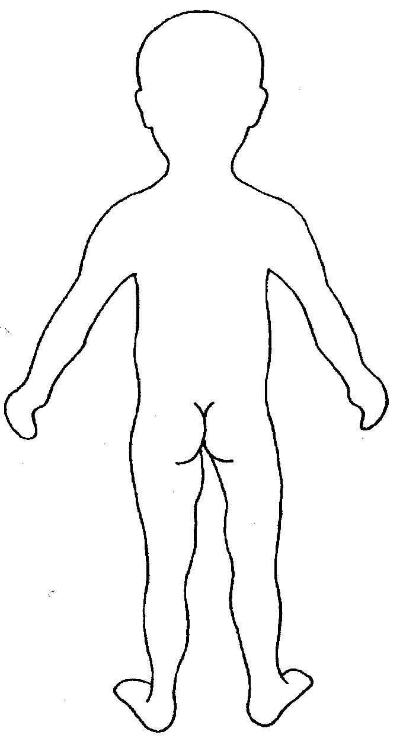

Front Back

